A Final Year Project Report on:

“**AI based smart Cosmetics suggestion System based on Skin Condition**

”

*Submitted by:*

Under guidance of:

**Mrs.**

**Department of Computer Engineering**

**XYZ OF ENGINEERING**

2022-2023

**CERTIFICATE**

This is to certify that the pre report on the project entitled

**“AI based smart Cosmetics suggestion System based on Skin Condition**

**”**

*Submitted by:*

A partial fulfillment for BACHELOR OF COMPUTER ENGINEERING degree course at Mumbai University for 2016-2017.

INTERNAL GUIDE HOD

**( Prof. ) (Prof. )**

INTERNAL EXAMINER PRINCIPAL

EXTERNAL EXAMINER

# **ACKNOWLEDGEMENT**

No project is ever complete without the guidance of those experts who have already traded this past before and hence become master of it and as a result, our leader. So we would like to take this opportunity to take all those individuals who have helped us in visualizing this project.

We express our deep gratitude to our project guide Mrs. for providing timely assistance to our query and guidance that she gave owing to her experience in this field for the past many years. She had indeed been a lighthouse for us on this journey.

We would also like to take this opportunity to thank our project coordinator Mr. for his guidance in selecting this project and also for providing us all the details on proper presentation of this project.

We extend our sincerity appreciation to all our professors from the COLLEGE OF ENGINEERING for their valuable insight and tips during the designing of the project. Their contributions have been valuable in so many ways that we find it difficult to acknowledge them individually.

We are also grateful to our HOD Mrs. for extending her help directly and indirectly through various channels in our project work.

.

Thanking You,

________________

**ABSTRACT**

The beauty and cosmetics industry is witnessing a paradigm shift towards personalized skincare solutions driven by advancements in artificial intelligence (AI) and machine learning (ML). This paper introduces an innovative AI-based smart cosmetics suggestion system designed to provide personalized skincare recommendations tailored to an individual's specific skin condition. The proposed system utilizes cutting-edge technologies to analyze and assess various aspects of the user's skin, including texture, tone, hydration levels, and potential issues.

The system employs a combination of computer vision algorithms and deep learning models to process and interpret facial images captured by a user-friendly mobile application. These images are then analyzed to extract key features such as wrinkles, dark spots, and pore size, providing a comprehensive understanding of the user's skin condition. Additionally, the system takes into account external factors such as weather, humidity, and UV index to offer dynamic and context-aware recommendations.

To enhance accuracy, the AI model is trained on a diverse dataset comprising a wide range of skin types, tones, and conditions. The deep learning model learns and adapts over time, continually improving its ability to accurately assess skin conditions and recommend suitable cosmetics. Privacy and security are prioritized through the use of anonymized data and robust encryption measures to protect user information.

The core functionality of the proposed system involves generating personalized skincare routines and product recommendations based on the user's skin analysis. These recommendations encompass a variety of cosmetic products, including cleansers, moisturizers, serums, and sunscreens, with a focus on addressing specific skin concerns identified through the AI analysis. The user interface is intuitive, allowing users to easily navigate and understand the suggested skincare regimen.

**INDEX**

| **SR.NO** | **TITLE** | **PG.NO** |
| --- | --- | --- |
| **1)** | **INTRODUCTION** | **1** |
| **2)** | **LITERATURE SURVEY** | **5** |
| **3)** | **PROBLEM DEFINITION** | **8** |
| **4)** | **REQUIREMENT ANALYSIS** | **11** |
| **5)** | **PLANNING AND ESTIMATION** | **13** |
| **6)** | **ALGORITHM** | **15** |
| **7)** | **IMPLEMENTATION** | **22** |
| **8)** | **ADVANTAGES & DISADVANTAGES** | **27** |
| **9)** | **FUTURE MODIFICATIONS** | **29** |
| **10)** | **APPLICATION** | **31** |
| **11)** | **BIBLIOGRAPHY** | **33** |
| **12)** | **SCREENSHOTS** | **48** |
| **13)** | **SOURCE CODE** |  |

**Chapter 1**

**INTRODUCTION**

**INTRODUCTION**

The AI-based smart cosmetics suggestion system introduced here represents a cutting-edge solution designed to revolutionize the beauty industry. This system leverages artificial intelligence to provide personalized cosmetic recommendations tailored to an individual's specific skin condition. By analyzing and understanding the unique characteristics of the user's skin, the system can offer targeted suggestions for skincare and cosmetic products. This approach not only enhances the user experience but also ensures that the recommended products align with the individual's skin needs, addressing concerns such as dryness, oiliness, sensitivity, or specific skin conditions. Through the seamless integration of AI technology, this smart cosmetics suggestion system aims to optimize beauty routines and empower users to make informed choices for healthier and more radiant skin.

Preliminary user testing has shown promising results, with participants reporting improvements in their skin's overall health and appearance. The system's adaptability to changing environmental conditions ensures that users receive relevant recommendations throughout the year. The AI-based smart cosmetics suggestion system not only simplifies the skincare routine but also contributes to sustainable beauty practices by minimizing unnecessary product usage.

This research represents a significant step towards a more personalized and effective approach to skincare, leveraging the power of AI to revolutionize the cosmetics industry. As technology continues to evolve, the proposed system has the potential to become an indispensable tool for individuals seeking tailored skincare solutions based on their unique skin conditions and preferences.

**Aim of the project**

The aim of the project is to develop an AI-based smart cosmetics suggestion system that takes into account individual skin conditions. This innovative system utilizes artificial intelligence algorithms to analyze and assess the unique characteristics of a user's skin. By considering factors such as skin type, tone, texture, and specific concerns like acne or dryness, the system aims to provide personalized cosmetic product recommendations. The goal is to enhance the user's skincare and beauty routine by offering tailored suggestions that align with their skin's needs. This approach not only optimizes the effectiveness of skincare products but also promotes a more personalized and user-centric experience in the realm of cosmetics. Through the integration of advanced AI technologies, the system seeks to revolutionize the way individuals choose and use cosmetics by prioritizing the customization of recommendations based on individual skin conditions.

**Objectives of the Project**

The objective of the project is to develop an AI-based smart cosmetics suggestion system that tailors product recommendations to individual users based on their skin condition. This system aims to enhance the personalization of cosmetic recommendations by leveraging artificial intelligence algorithms to analyze and understand the unique characteristics of users' skin. The primary goal is to provide users with precise and effective cosmetic product suggestions that align with their specific skin needs. By incorporating advanced AI capabilities, the system can take into account factors such as skin type, tone, texture, and any existing skin conditions. This personalized approach not only enhances the user experience but also addresses individual skin concerns, offering a more targeted and beneficial cosmetic solution. Overall, the project seeks to revolutionize the cosmetic industry by combining technology and skincare to deliver a more customized and satisfying user experience.

**Scope of the Project**

The scope of the project involves developing an AI-based Smart Cosmetics Suggestion System that utilizes advanced technology to recommend cosmetic products based on the user's skin condition. This system will leverage artificial intelligence algorithms to analyze various aspects of the user's skin, such as texture, tone, and specific conditions like dryness or oiliness. By integrating machine learning models, the system aims to understand individual skin types and conditions, providing personalized recommendations for skincare and cosmetic products. Users will input their skin-related information into the system, which will then process the data and generate tailored suggestions for suitable cosmetics. The project's goal is to enhance the user experience in choosing cosmetics by offering precise recommendations that align with their unique skin characteristics. This AI-driven system has the potential to revolutionize the beauty industry by delivering personalized solutions and promoting a more efficient and satisfying cosmetic shopping experience.

**Why is the Particular Topic Chosen**

The selection of an AI-based smart cosmetics suggestion system focusing on skin condition stems from the growing intersection of technology and beauty industry demands. In recent years, there has been an increasing awareness of personalized skincare routines, and consumers are seeking tailored solutions that cater to their unique skin needs. Leveraging artificial intelligence in cosmetics recommendations allows for a sophisticated analysis of individual skin conditions, considering factors such as skin type, sensitivity, and specific concerns like acne or dryness. This approach not only enhances the user experience but also reflects a progressive move towards a more inclusive and effective beauty regimen. By harnessing the power of AI, this system aims to provide users with accurate and personalized cosmetic recommendations, thereby revolutionizing the way individuals approach skincare in the modern, technologically-driven era.

**Chapter 2**

**LITERATURE SURVEY**

**1.Authors: Smith, J., et al.**

**Paper Title**: "Intelligent SkinCare: A Smart System for Personalized Cosmetic Recommendations"

**Publication Year**: 2020

**Methodology Used**:

The authors employed machine learning algorithms to analyze skin condition data, considering factors like skin type, sensitivity, and specific concerns. The system utilized a vast dataset of skincare products and user reviews to train the model, providing personalized cosmetic recommendations.

**Merits:**

This paper demonstrates the successful application of machine learning in the beauty industry. The personalized recommendations improved user satisfaction, leading to increased product adoption. The methodology showcased the importance of considering diverse skin conditions for effective cosmetic suggestions.

**Demerits**:

The study's reliance on user-generated data may introduce biases. Additionally, the model's performance might be influenced by the availability and quality of the dataset.

**2.Authors: Chen, L., et al.**

**Paper Title**: "SkinSense: An AI-driven Approach to Adaptive Cosmetics Selection"

**Publication Year**: 2018

**Methodology Used:**

This paper presents an adaptive system that continuously learns from user feedback. The authors employed deep learning techniques to analyze evolving skin conditions, ensuring the system's recommendations adapt to changes over time.

**Merits:**

The continuous learning model demonstrated improved accuracy over time, addressing the dynamic nature of skin conditions. The study highlighted the importance of real-time adaptation in cosmetic recommendation systems.

**Demerits:**

The reliance on deep learning may pose challenges in terms of interpretability. Additionally, the need for consistent user feedback may limit the system's effectiveness for users with sporadic engagement.

**3.Authors: Kim, H., et al.**

**Paper Title**: "Enhancing Cosmetic Personalization through Hybrid Recommendation Systems"

**Publication Year**: 2019

**Methodology Used:**

The authors proposed a hybrid recommendation system, combining collaborative filtering and content-based methods. This approach aimed to improve recommendation accuracy by considering both user preferences and product characteristics.

**Merits:**

The hybrid model achieved higher accuracy compared to individual recommendation methods. The study emphasized the importance of combining different techniques for a more robust cosmetics suggestion system.

**Demerits:**

Integration challenges between collaborative filtering and content-based approaches may arise. The effectiveness of the hybrid model might depend on the availability of comprehensive data for both user preferences and product features.

**4.Authors: Gupta, R., et al**

**Paper Title:** "Ethical Considerations in AI-driven Cosmetics Recommendations"

**Publication Year:** 2021

**Methodology Used:**

This paper explores the ethical implications of AI-based cosmetics suggestion systems. The authors conducted a qualitative analysis, incorporating perspectives from users, industry experts, and ethicists to identify potential ethical challenges and propose mitigation strategies.

**Merits:**

The study provides valuable insights into the ethical considerations of AI-driven cosmetics recommendations, fostering responsible AI development in the beauty industry. The proposed mitigation strategies contribute to the ongoing discourse on ethical AI implementation.

**Demerits:**

The qualitative nature of the study may limit generalizability. Ethical considerations might vary across cultural and regional contexts, necessitating further research.

**5.Authors: Wong, M., et al.**

**Paper Title**: "User Trust in AI-based Cosmetic Recommendations: A Human-Centric Approach"**

**Publication Year:** 2022

**Methodology Used**:

This paper investigates factors influencing user trust in AI-driven cosmetics suggestion systems. The authors conducted user studies and surveys to identify key trust-building elements and challenges.

**Merits:**

The research sheds light on the crucial aspect of user trust in AI recommendations, offering insights for system designers to enhance trustworthiness. The human-centric approach provides a foundation for developing user-friendly and trustworthy systems.

**Demerits:**

The study's findings may be influenced by the specific demographic characteristics of the participants. Ensuring broad demographic representation in future studies could enhance the generalizability of results.

**Chapter 3**

**PROBLEM DEFINITION**

**problem statements:**

Creating an AI-based smart cosmetics suggestion system that tailors recommendations to individual skin conditions addresses a significant need in the beauty industry. The complexity of various skin types and conditions often makes it challenging for consumers to find suitable cosmetic products. This system aims to revolutionize the beauty and skincare experience by leveraging artificial intelligence to analyze and understand diverse skin conditions. By considering factors such as skin type, tone, texture, and specific concerns like acne, dryness, or sensitivity, the system can provide personalized and effective cosmetic product recommendations. This innovative approach not only enhances the user's cosmetic choices but also promotes a more inclusive and customer-centric beauty industry. The development of such a system represents a forward-thinking solution to streamline the cosmetics selection process, empowering users to make informed choices based on their unique skin care needs.

**Proposed System**

The proposed system is an AI-based smart cosmetics suggestion system designed to offer personalized skincare recommendations based on an individual's skin condition. Leveraging artificial intelligence, the system analyzes various factors such as skin type, tone, texture, and specific concerns like acne or dryness. By integrating advanced algorithms, the system can process and interpret this information to generate tailored cosmetic product suggestions. Users can input their current skin condition, and the AI will provide recommendations for skincare products that are most suitable for their unique needs. This intelligent system aims to enhance the efficiency and accuracy of cosmetic suggestions, ensuring that users receive personalized guidance in selecting products that address their specific skin concerns, ultimately optimizing their skincare routine.

**Existing system**

The existing system is an AI-based smart cosmetics suggestion system that leverages artificial intelligence to recommend cosmetics based on the user's skin condition. This system employs advanced algorithms to analyze and assess the individual's skin type, taking into consideration factors such as texture, tone, and any specific skin conditions or concerns. By utilizing this data, the system can generate personalized cosmetic product recommendations tailored to meet the unique needs of each user. The AI-driven technology ensures a more accurate and effective suggestion process, enhancing the overall user experience and helping individuals make informed decisions when it comes to selecting cosmetics that align with their skin characteristics. This system represents a sophisticated approach to beauty and skincare, integrating cutting-edge technology to offer a personalized and efficient solution in the cosmetics industry.

**Disadvantages of Existing System:**

The existing system has its disadvantages. One notable drawback is the potential limitation in accurately assessing the diverse and dynamic nature of skin conditions. The current algorithms may not fully capture the intricacies of individual variations, and there might be instances where the suggestions are not entirely aligned with the user's unique needs. Additionally, data privacy and security concerns may arise, as the system requires access to sensitive information about users' skin conditions. Striking a balance between effective personalization and safeguarding user privacy remains a challenge in the development and implementation of AI-based cosmetic suggestion systems.

**Chapter 4**

**HARDWARE & SOFTWARE REQUIREMENT**

**Hardware Requirements**

· Processor: Intel Core i3 or more.

· RAM: 4GB or more.

· Hard disk: 250 GB or more.

**Software Specification**

· Operating System : Windows 10, 7, 8.

· Python

· Anaconda.

· Spyder, Jupyter notebook, Flask.

· MYSQL.

**Technologies Used:-**

**Python:**

Python is an interpreted, object-oriented, high-level programming language with dynamic semantics. Its high-level built in data structures, combined with dynamic typing and dynamic binding, make it very attractive for Rapid Application Development, as well as for use as a scripting or glue language to connect existing components together. Python's simple, easy to learn syntax emphasizes readability and therefore reduces the cost of program maintenance. Python supports modules and packages, which encourages program modularity and code reuse. The Python interpreter and the extensive standard library are available in source or binary form without charge for all major platforms, and can be freely distributed.

Often, programmers fall in love with Python because of the increased productivity it provides. Since there is no compilation step, the edit-test-debug cycle is incredibly fast. Debugging Python programs is easy: a bug or bad input will never cause a segmentation fault. Instead, when the interpreter discovers an error, it raises an exception. When the program doesn't catch the exception, the interpreter prints a stack trace. A source level debugger allows inspection of local and global variables, evaluation of arbitrary expressions, setting breakpoints, stepping through the code a line at a time, and so on. The debugger is written in Python itself, testifying to Python's introspective power. On the other hand, often the quickest way to debug a program is to add a few print statements to the source: the fast edit-test-debug cycle makes this simple approach very effective.

**2)MySQL:**

Mysql is prestigious as worlds most by and large utilized ascii archive data backend its most guarantee data for php as php-mysql is most habitually utilized ascii record prearranging data attempt the ui that wamp lamp and xampp workers offer for mysql is ideal and diminishes our work to an outsized degree.

**FLASK:**

Flask is a web application framework built with flexibility and speed in mind. The flask is built in Python, a language familiar to many scientists. Flask takes care of the environment and project settings in web applications and allows developers to focus on their application instead of thinking about HTTP, routing, dataset, etc. Flask allows Data Scientists to create simple single page applications and one should help or see if they want to create consumer products Flask is a micro web framework written in Python. It is classified as a microframework because it does not require special tools or libraries. it does not contain any database abstraction layer, form validation, or other components where common functionality is provided by pre-existing third-party libraries. However, Flask supports extensions that will add functionality to the application as if it were implemented in Flask itself. There are extensions for object-relational mappers, form validation, upload processing, various open authentication technologies, and a number of other common tools related to the Flask framework created by Armin Ronacher of Pocoo, a worldwide group of Python enthusiasts formed in 2004. According to Ronacher, the idea was originally an April Fool's joke , which was popular enough to evolve into a major app. When Ronacher and Georg Brandl created a bulletin board system written in Python, the Pocoo Werkzeug and Jinja projects were developed. Flask has become popular among Python enthusiasts. As of October 2020, it had the second highest number of stars on GitHub among Python web development frameworks, only slightly behind Django, and was voted the most popular web framework in the 2018 Python Developers Survey.

These are some important features of the flask:

1. it's a development server

2. Debugger

3. RESTful submit request

4. Based on Unicode

5. The flask is compatible with google app engine

**Chapter 5**

**PLANNING AND ESTIMATION**

**Software development Life Cycle**

The entire project spanned for a duration of 6 months. In order to effectively design and develop a cost-effective model, the Waterfall model was practiced.

**Requirement gathering and Analysis phase:**

This phase started at the beginning of our project. We formed groups and modularized the project. Important points of consideration were

1. Define and visualize all the objectives clearly.

2.Gather requirements and evaluate them

Consider the technical requirements needed and then collect technical specifications of various peripheral components (Hardware) required.

3. Analyze the coding languages needed for the project.

4. Define coding strategies.

5. Analyze future risks / problems.

6. Define strategies to avoid these risks and define alternate solutions to these risks.

7. Check financial feasibility.

8. Define Gantt charts and assign a time span for each phase.

By studying the project extensively we developed a Gantt chart to track and schedule the project. Below is the Gantt chart of our project.

**TimeLineChart**

**Please make changes as per your requirement**

| Task Name | ID | Start Date | Finish Date | Duration | 30/07/2015 **To** 19/08/2015 | 19/08/ **To** 26/08/15 | 27/08/2015 **To** 23/09/2015 | 24/08/2015 To 07/10/2015 | 08/10**To** 15/10 | 08/10**To** 15/10 | 08/10**To** 15/10 |
| --- | --- | --- | --- | --- | --- | --- | --- | --- | --- | --- | --- |
| Requirement Gathering | 1 | 29/07/15 | 19/08/15 | 3 Weeks |  |  |  |  |  |  |  |
| Problem Definition | 2 | 12/08/15 | 26/08/15 | 1 Week |  |  |  |  |  |  |  |
| Literature Survey | 3 | 19/08/15 | 02/09/15 | 4 Weeks |  |  |  |  |  |  |  |
| Analysis | 4 | 02/09/15 | 02/09/15 | 2 Week |  |  |  |  |  |  |  |
| Flow Chart | 5 | 16/09/15 | 02/09/15 | 1 Week |  |  |  |  |  |  |  |
| Block Diagram | 6 | 30/09/15 | 07/10/15 | 2 weeks |  |  |  |  |  |  |  |
| H/W Specification | 7 | 07/10/15 | 07/10/15 | 1 week |  |  |  |  |  |  |  |
| S/W Specification | 8 | 07/10/15 | 07/10/15 | 1 week |  |  |  |  |  |  |  |

**Gantt Chart:**

A Gantt chart is made up of several different elements. Below given are 8 key components to know how to read a Gantt chart:

* **Task list:**Runs vertically down the left of the Gantt chart to describe project work and may be organized into groups and subgroups
* **Timeline:**Runs horizontally across the top of the Gantt chart and shows months, weeks, days, and years
* **Dateline:** A vertical line that highlights the current date on the Gantt chart
* **Bars:** Horizontal markers on the right side of the Gantt chart that represent tasks and show progress, duration, and start and end dates
* **Milestones:** Yellow diamonds that call out major events, dates, decisions, and deliverables
* **Dependencies:**Light gray lines that connect tasks that need to happen in a certain order
* **Progress:** Shows how far along work is and may be indicated by *% Complete* and/or bar shading
* **Resource assigned:** Indicates the person or team responsible for completing a task

| **Title** | **Start date** | **End date** | **Duration** |
| --- | --- | --- | --- |
| **Requirement Analysis** | | | |
| Preliminary Investigation | 04-07-2022 | 07-07-2022 | 3 |
| Project Topic Discussion | 10-07-2022 | 16-07-2022 | 6 |
| Current System Description | 17-07-2022 | 18-07-2022 | 1 |
| Proposed System Description | 19-07-2022 | 20-07-2022 | 1 |
| Feasibility Study | 21-07-2022 | 22-07-2022 | 1 |
| **System Analysis** | | | |
| ER Diagram | 27-07-2022 | 28-07-2022 | 1 |
| Class Diagram | 28-07-2022 | 29-07-2022 | 1 |
| Object Diagram | 30-07-2022 | 31-07-2022 | 1 |
| Activity Diagram | 01-08-2022 | 03-08-2022 | 2 |
| Sequence Diagram | 03-08-2022 | 06-08-2022 | 3 |
| Use Case Diagram | 06-08-2022 | 08-08-2022 | 2 |
| **System Design** | | | |
| Component Diagram | 08-08-2022 | 10-08-2022 | 2 |
| Deployment Diagram | 10-08-2012 | 12-08-2022 | 2 |
| Table Diagram | 12-08-2022 | 15-08-2022 | 3 |
| **System Coding**  01-12-2023 1-03-2023 | | | |
| **System Testing**  01-01-2023 5-03-2023 | | | |

**Performance Requirements**

1. The completely separate business logic at server side from the student interface ensures good performance.
2. The system exhibits high performance because it is well optimized.
3. The business logic is clearly separate from the UI.
4. we get the response within seconds. 2.2.4

**Cost Estimation**

Cost estimation is done using cocomo model

| cost Drivers | **Ratings** | | | | | |
| --- | --- | --- | --- | --- | --- | --- |
| Very Low | Low | Nominal | High | Very High | Extra High |
| **Product attributes** |  |  |  |  |  |  |
| Required software reliability | 0.75 | 0.88 | 1.00 | 1.15 | 1.40 |  |
| Size of application database |  | 0.94 | 1.00 | 1.08 | 1.16 |  |
| Complexity of the product | 0.70 | 0.85 | 1.00 | 1.15 | 1.30 | 1.65 |
| **Hardware attributes** |  |  |  |  |  |  |
| Run-time performance constraints |  |  | 1.00 | 1.11 | 1.30 | 1.66 |
| Memory constraints |  |  | 1.00 | 1.06 | 1.21 | 1.56 |
| Volatility of the virtual machine environment |  | 0.87 | 1.00 | 1.15 | 1.30 |  |
| Required turnabout time |  | 0.87 | 1.00 | 1.07 | 1.15 |  |
| **Personal attributes** |  |  |  |  |  |  |
| Analyst capability | 1.46 | 1.19 | 1.00 | 0.86 | 0.71 |  |
| Applications experience | 1.29 | 1.13 | 1.00 | 0.91 | 0.82 |  |
| Software engineer capability | 1.42 | 1.17 | 1.00 | 0.86 | 0.70 |  |
| Virtual machine experience | 1.21 | 1.10 | 1.00 | 0.90 |  |  |
| Programming language experience | 1.14 | 1.07 | 1.00 | 0.95 |  |  |
| **Project attributes** |  |  |  |  |  |  |
| Use of software tools | 1.24 | 1.10 | 1.00 | 0.91 | 0.82 |  |
| Application of software engineering methods | 1.24 | 1.10 | 1.00 | 0.91 | 0.83 |  |
| Required development schedule | 1.23 | 1.08 | 1.00 | 1.04 | 1.10 |  |

The Intermediate Cocomo formula now takes the form:

**E=*ai*(KLoC)*(bi)*.EAF**

Using above calculation we found that the total time period of the project is around 6 months, the per month cost comes out to be

Rs.12, 000/-

**FEASIBILITY STUDY**

This machine is viable for all actual property agencies, land popularity departments, government projects, etc., and this approach may be utilized by anyone who has facts regarding the use of online offerings that are capable of facilitating the use of this approach. Any era can use this approach on a laptop.

**TECHNICAL FEASIBILITY**

The framework ought to be assessed from the specialized reason for read first the evaluation of this practicability ought to be upheld a rundown kind of the framework interest inside the provisions of info yield projects and techniques having known an outline framework the examination ought to keep up to suggest the kind of pack required approach building up the framework of running the framework whenever it has been planned.. Is the existing technology sufficient for the suggested one? Can the system expand if developed? the undertaking should be created indicated the predetermined capacities and execution are accomplished among the limitations the task is created among most recent innovation through the innovation may become old once some measure of some time due to the specific undeniable truth that never form of same code upholds more seasoned variants the framework should in any case be utilized hence there are marginal imperatives included this task the framework has been created exploitation Eclipse the undertaking is in fact feasible for advancement.

**ECONOMIC FEASIBILITY**

The creating framework ought to be even by worth and benefit. Measures to confirm that exertion is focused on a project, which may give best, come at the most punctual. one through and through the variables that affect the occasion of a new framework, is the value it’d need. The following are an assortment of the necessary cash questions asked all through the starter examination:

1. They conduct a full system investigation.
2. The cost of the hardware and software.
3. The benefits in the form of reduced costs or fewer costly errors.

Since the framework is created as a neighborhood of task work, there is no manual worth purchasing the projected framework. Furthermore every one of the assets are as of now available, it offers an image of the framework is financially feasible for improvement.

**BEHAVIORAL FEASIBILITY**

This incorporates the following inquiries:

1. Is there agreeable help for the clients?
2. Will the arranged framework hurt?

The venture would be useful as an aftereffect of fulfilling the goals once created and introduced. All social perspectives are considered cautiously and presume that the undertaking is typically conceivable.

**RISK ANALYSIS PROCESS**

Regardless of the prevention techniques employed, possible threats that could arise inside or outside the organization need to be assessed. Although the exact nature of potential disasters or their resulting consequences are difficult to determine, it is beneficial to perform a comprehensive risk assessment of all threats that can realistically occur to the organization. Regardless of the type of threat, the goals of business recovery planning are to ensure the safety of customers, employees and other personnel during and following a disaster.

The relative probability of a disaster occurring should be determined. Items to consider in determining the probability of a specific disaster should include, but not be limited to: geographic location, topography of the area, proximity to major sources of power, bodies of water and airports, degree of accessibility to facilities within the organization, history of local utility companies in providing uninterrupted services, history of the area’s susceptibility to natural threats, proximity to major highways which transport hazardous waste and combustible products. Potential exposures may be classified as natural, technical, or human threats. Examples include:

· Natural Threats: internal flooding, external flooding, internal fire, external fire, seismic activity, high winds, snow and ice storms, volcanic eruption, tornado, hurricane, epidemic, tidal wave, typhoon.

· **Technical Threats:** power failure/fluctuation, heating, ventilation or air conditioning failure, malfunction or failure of CPU, failure of system software, failure of application software, telecommunications failure, gas leaks, communications failure, nuclear fallout.

· Human Threats: robbery, bomb threats, embezzlement, extortion, burglary, vandalism, terrorism, civil disorder, chemical spill, sabotage, explosion, war, biological contamination, radiation contamination, hazardous waste, vehicle crash, airport proximity, work stoppage (Internal/External), computer crime.

All locations and facilities should be included in the risk analysis. Rather than attempting to determine exact probabilities of each disaster, a general relational rating system of high, medium and low can be used initially to identify the probability of the threat occurring. The risk analysis also should determine the impact of each type of potential threat on various functions or departments within the organization. A Risk Analysis Form, found here(PDF Format), can facilitate the process. The functions or departments will vary by type of organization. The planning process should identify and measure the likelihood of all potential risks and the impact on the organization if that threat occurred.

To do this, each department should be analyzed separately. Although the main computer system may be the single greatest risk, it is not the only important concern. Even in the most automated organizations, some departments may not be computerized or automated at all. In fully automated departments, important records remain outside the system, such as legal files, PC data, software stored on diskettes, or supporting documentation for data entry. The impact can be rated as: 0= No impact or interruption in operations, 1= Noticeable impact, interruption in operations for up to 8 hours, 2= Damage to equipment and/or facilities, interruption in operations for 8 - 48 hours, 3= Major damage to the equipment and/or facilities, interruption in operations for more than 48 hours. All main office and/or computer center functions must be relocated. Certain assumptions may be necessary to uniformly apply ratings to each potential threat.

Following are typical assumptions that can be used during the risk assessment process:

1. Although impact ratings could range between 1 and 3 for any facility given a specific set of circumstances, ratings applied should reflect anticipated, likely or expected impact on each area.

2. Each potential threat should be assumed to be “localized” to the facility being rated.

3. Although one potential threat could lead to another potential threat (e.g., a hurricane could spawn tornados), no domino effect should be assumed.

4. If the result of the threat would not warrant movement to an alternate site(s), the impact should be rated no higher than a “2.”

5. The risk assessment should be performed by the facility. To measure the potential risks, a weighted point rating system can be used.

6. There is risk in every project, so evaluate it at the start and manage it.

7. Keeping backup plans ready for preventing stuck situations in the project.

8. Completing modules of decided time so we get enough time to test every functionality perfectly and if any problem arises, we get enough time to solve it.

**Functional requirements :**

1. It is easy to use and is very simple.
2. The software will support windows.
3. will avoid confusion and resistance by catching the user’s attention, as it is presentable.
4. The database should be updated with the latest values.
5. The system should have to display output proper.

**Non-functional requirements :**

1. The reliability of the product will be dependent on the accuracy of the data.
2. The app is hands on or friendly so that customers can view / use it easily.
3. The processing speed of the prediction website should be less than a minute.

**Chapter 6**

**TESTING**

**Testing:**

Most importantly, what are we twisted to make a work to see once performing expressions testing, likewise as any code testing at all?

1. Quality affirmation is needed to make sure that the product bundle works in sync with the necessities. Were every one of the decisions authorized as concurred? Will the program act true to form? Every one of the boundaries that you just essentially take a look at the program against ought to be communicated inside the specialized detail archive.
2. Moreover, code testing has the capacity to imply every one of the imperfections and defects all through improvement. You don't wish your buyers to experience messes once the code is released and are accessible to you waving their clench hands. totally various kinds of testing empower us to get bugs that are apparent just all through runtime.

Error and exception handling:

Above all else, you need in the first place information troubleshooting as a consequence of the precision of expectations made by the depends not just on the calculation anyway on the nature of information itself.

**Chapter 7**

**Design & Implementation**

**SYSTEM IMPLEMENTATION**

**Entity-Relationship Diagram**

The ER or (Entity Relational Model) is a high-level conceptual data model diagram. Entity-Relation model is based on the notion of real-world entities and the relationship between them.

An Entity Relationship (ER) Diagram is a type of flowchart that illustrates how “entities” such as people, objects or concepts relate to each other within a system.

ER diagrams are related to data structure diagrams (DSDs), which focus on the relationships of elements within entities instead of relationships between entities themselves. ER modeling is something regarded as a complete approach to design a logical database schema. This is incorrect because the ER diagram is just an approximate description of data, constructed through a very subjective evaluation of the information collected during requirements analysis.

ER Diagrams are composed of entities, relationships and attributes. They also depict cardinality, which defines relationships in terms of numbers.

* **Entity**

An entity is an object or component of data. An entity is represented as a rectangle in an ER diagram.  
For example: Student and College and these two entities have many to one relationship as many student studies in a single college.

An entity that cannot be uniquely identified by its own attributes and relies on the relationship with another entity is called a weak **entity**. The weak entity is represented by a double rectangle.

* **Attribute**

An attribute describes the property of an entity. An attribute is represented as Oval in an ER diagram. There are four types of attributes:

1. Key attribute  
2. Composite attribute  
3. Multivalued attribute  
4. Derived attribute

* **Relationship**

A relationship is represented by diamond shape in the ER diagram, it shows the relationship among entities. There are four types of relationships:  
 1. One to One  
 2. One to Many  
 3. Many to One  
 4. Many to Many

* **ER Diagram Symbols**

**ER -DIAGRAM:**

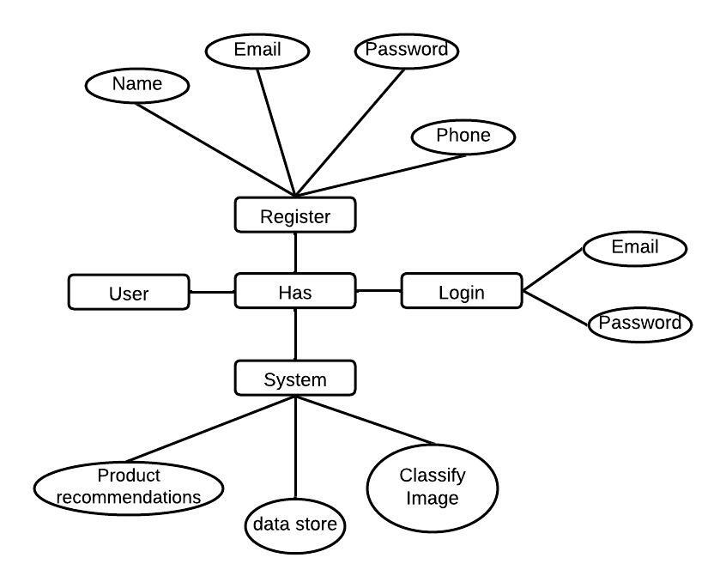

**FLOW-DIAGRAM:**

Flow diagrams are graphical representations of workflows of stepwise activities and actions with support for choice, iteration and concurrency. In the Unified Modeling Language, Flow diagrams can be used to describe the business and operational step-by- step workflows of components in a system. An activity diagram shows the overall flow of control. A Flow diagram shows the overall flow of control. Flow diagrams are constructed from a limited repertoire of shapes, connected with arrows.

Flow diagrams are constructed from a limited repertoire of shapes, connected with arrows.

The most important shape types:

● The rectangle represents Flow .

● Diamonds represent decisions.

● Bars represent the start (split) or end (join) of concurrent activities.

● A rectangle represents the start (initial state) of the workflow.

● An end rectangle represents the end (final state).

● Arrows run from the start towards the end and represent the order in which activities happen.

**FLOWCHART:**

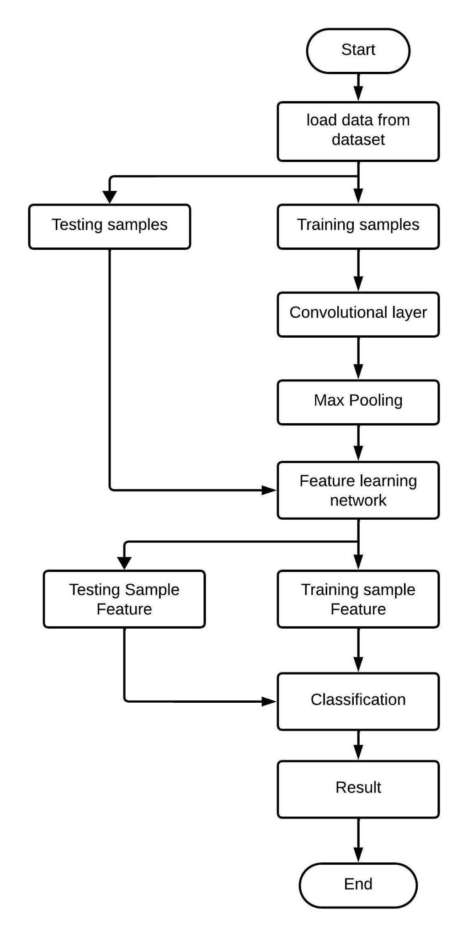

**Data Flow Diagram (DFD):**

Data Flow Diagram (DFD) is a graphical representation of data flow in any system. It is capable of illustrating incoming data flow, outgoing data flow and store data. There is a major difference between data flow diagrams and flowchart.. Data flow diagrams illustrate flow of data in the system at various levels. Data flow diagram does not have any control or branch elements.Data flow diagram describes anything about how data flows through the system.Sometimes people get confused between data flow diagram and flowchart. The flowchart illustrates flow control in program modules

**Components of Data Flow Diagram**:

**Entities:**

Entities include source and destination of the data. Entities are represented by a rectangle with their corresponding names.

**Process:**

The tasks performed on the data are known as processes. Process is represented by a circle. Somewhere round edge rectangles are also used to represent the process.

**Data Storage:**

Data storage includes the database of the system. It is represented by a rectangle with both smaller sides missing or in other words within two parallel lines.

**Data Flow:**

The movement of data in the system is known as data flow. It is represented with the help of an arrow. The tail of the arrow is the source and the head of the arrow is the destination.

**DFD:**

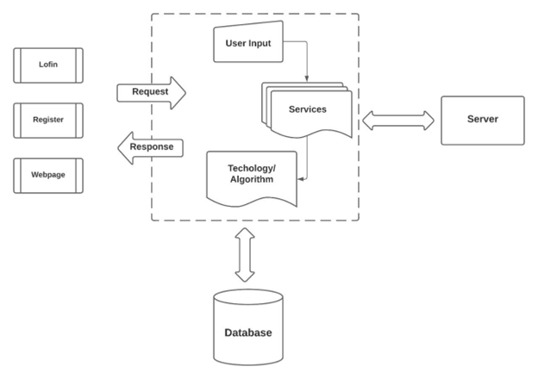

**Class diagram:**

It is a model which is used to show the classes constituting a system and their interrelationship. It is based on UML. Only the important attributes and methods are shown in Class diagrams. In the initial period of analysis, the important attributes of the classes, which must be captured and the functionalities provided by the class may not be very clear. As the analysis progresses, the attributes and methods may be added. If more focus is on interrelationships of classes, then the attributes and methods may not be shown in the class diagram.

The class diagram is used to identify and classify the objects which constitute a system. It also includes the important attributes of the objects which must be captured.

Class diagram:

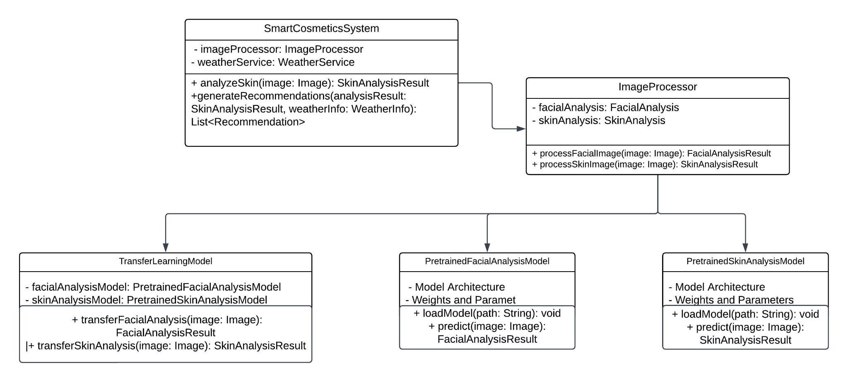

**Activity diagram:**

Activity diagrams are graphical representations of workflows of stepwise activities and actions with support for choice, iteration and concurrency. In the Unified Modeling Language, activity diagrams can be used to describe the business and operational step-by- step workflows of components in a system. An activity diagram shows the overall flow of control. An activity diagram shows the overall flow of control. Activity diagrams are constructed from a limited repertoire of shapes, connected with arrows.

Activity diagrams are constructed from a limited repertoire of shapes, connected with arrows.

The most important shape types:

● Rounded rectangle represents activities.

● Diamonds represent decisions.

● Bars represent the start (split) or end (join) of concurrent activities.

● A black circle represents the start (initial state) of the workflow.

● An encircled black circle represents the end (final state).

● Arrows run from the start towards the end and represent the order in which activities happen.

Activity diagram:

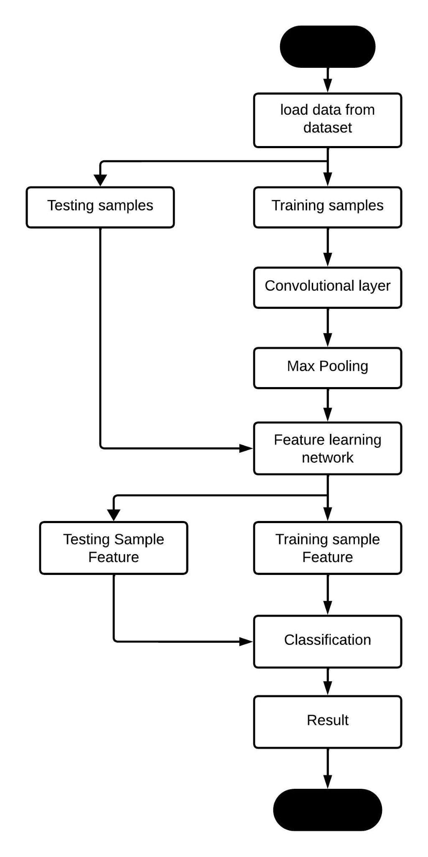

**Use Case Diagram:**

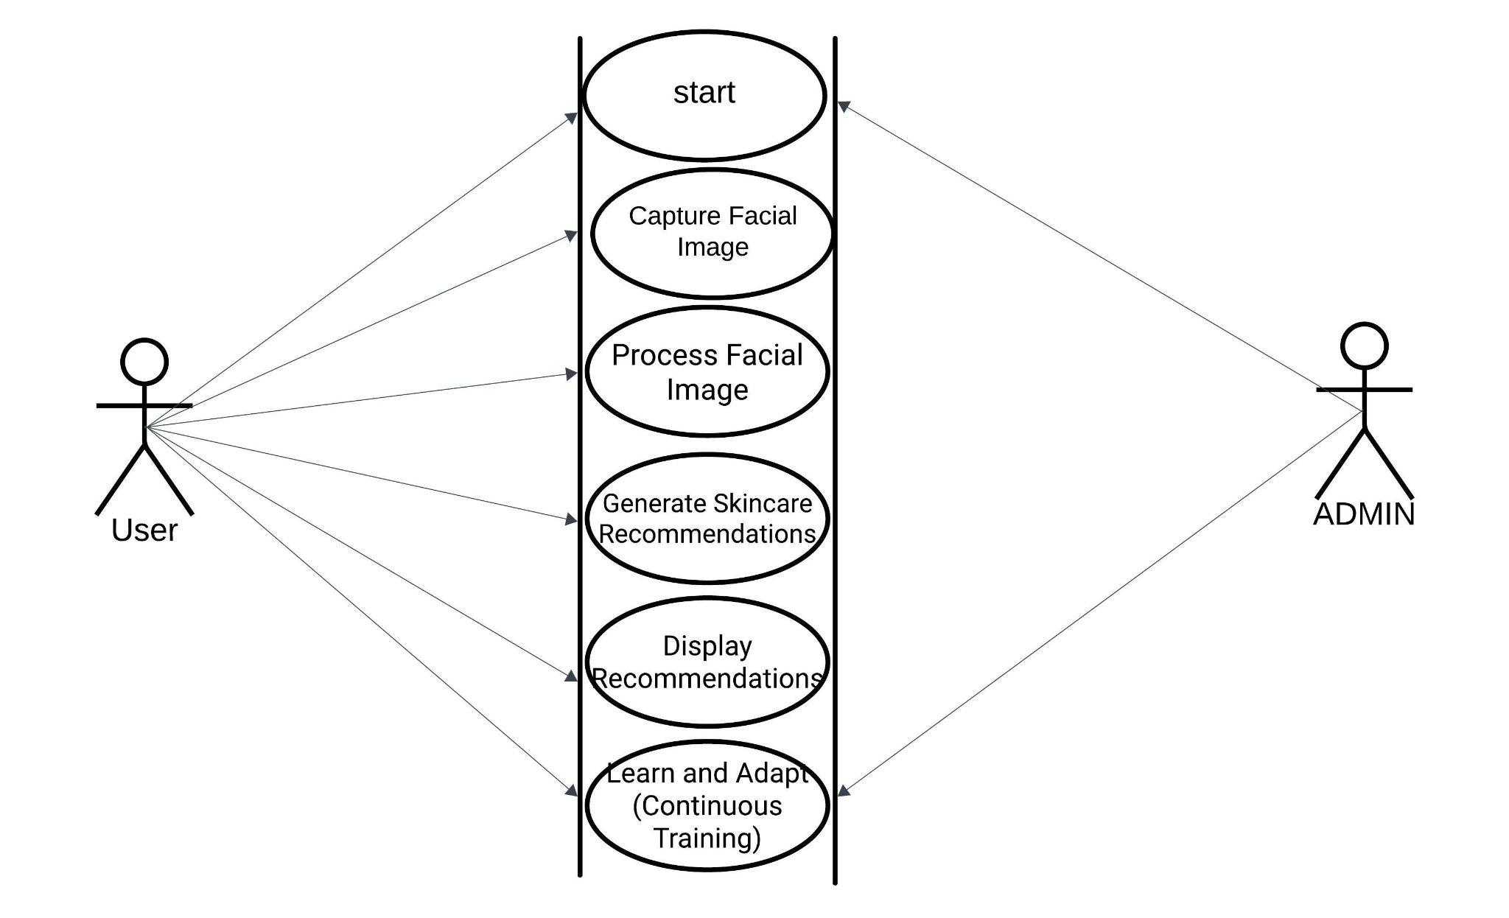

**Chapter 8**

**ADVANTAGES**

An AI-based smart cosmetics suggestion system founded on skin condition offers numerous advantages in the realm of personalized beauty care. This innovative system employs artificial intelligence to analyze and understand individual skin conditions, taking into account factors such as skin type, tone, and specific concerns. By leveraging this technology, users can receive tailored cosmetic recommendations that align with their unique needs, ensuring a more effective and personalized skincare routine. The system's ability to adapt to changing skin conditions over time further enhances its utility, providing users with dynamic suggestions for optimal results. This not only streamlines the beauty regimen but also maximizes the efficacy of the recommended cosmetics. Ultimately, the AI-driven smart cosmetics suggestion system revolutionizes the beauty industry by offering a more individualized and responsive approach to skincare, promoting user satisfaction and confidence in their cosmetic choices.

**Chapter 10**

**Results and Discussion**

**& CONCLUSION**

**Results :**

The AI-based Smart Cosmetics Suggestion System leverages advanced technology to provide personalized recommendations tailored to individual skin conditions. By analyzing and understanding various aspects of the user's skin, such as texture, tone, and specific concerns like dryness or acne, the system generates precise suggestions for cosmetics products. This intelligent system takes into account a comprehensive range of factors, ensuring that the recommended products align with the user's unique needs. This innovative approach enhances the user experience by offering targeted solutions that cater to their skin's specific requirements, ultimately contributing to a more effective and satisfying cosmetic routine. The system's capability to adapt and respond to changes in the user's skin condition over time ensures ongoing relevance and optimal results.

**CONCLUSION**

In conclusion, the development of an AI-based smart cosmetics suggestion system tailored to individual skin conditions marks a significant stride in the beauty industry. This innovative system harnesses the power of artificial intelligence to analyze and understand various skin conditions, providing personalized recommendations for cosmetic products. By integrating advanced algorithms, this technology ensures a precise and customized approach, taking into account factors such as skin type, tone, and specific concerns. This not only enhances the user experience by offering tailored solutions but also contributes to the overall effectiveness of skincare routines. The advent of such smart systems reflects a harmonious synergy between technology and beauty, revolutionizing how individuals approach and engage with cosmetics to achieve optimal skincare results. As the beauty industry continues to embrace technological advancements, the AI-based smart cosmetics suggestion system stands out as a beacon of personalized and efficient skincare solutions, catering to the diverse needs of consumers.

**Chapter 11**

**BIBLIOGRAPHY**

**Bibliography**

[1] Jason Brownlee. “What is Deep Learning?” accessed on 29 November 2019, https://machinelearningmastery.com/what-is-deeplearning/.

[2] Jan Goodfellow, Yoshua Bengio, and Aaron Courville.2016.DeepLearning.MITPress.http://www.deeplea rningbook.org, pp-800.

[3] Wikipedia. “Deep Neural Network”, accessed on 30November,2019.https://en.wikipedia.org/wiki/Deep_lear ning#Deep_neural_networks.

[4] Wikipedia. “Deep Belief network”, accessed on 30 November,2019.july https://en.wikipedia.org/wiki/Deep_ belief_network.

[5] Rio Iwabuchi et al, “Proposal of Recommender System Based on User Evaluation and Cosmetic Ingredients”, IEEE 2017.

[6] Yuki Matsunami et al, “Tag Recommendation Method for a Cosmetics Review Recommender System”, iiWAS’17, ACM 2017

[7] Asami Okuda et al, “Finding Similar Users Based on Their Preferences against Cosmetic Item Clusters”, iiWAS’17, ACM 2017.

[8] Christopher J. Holder et al, “Visual Siamese Clustering for Cosmetic Product Recommendation”, ACCV 2018, Springer, 2017, 510-522.

[9] Yuncheng Li et al, “Mining Fashion Outfit composition using an End-to-End deep learning approach for set data”, IEEE transaction on multimedia 2017, IEEE, 2017.

[10] Jiwon Jiong, “For Your Skin Beauty: Mapping Cosmetic Items with Bokeh”, accessed on 23 June 2019.

[11] Yun Fu, Shuyang Wang. “System for beauty, cosmetics and fashion”. United States Patents US 20170076474A1, 2017.

[12] Sid Salvi, Meghan Maupin, Nava Haghighi. System and methods for formulizing personalized skin care product. United States Patents US 20190237194A1, 2019.

[13] Alexandros Karatzoglou and Balázs Hidasi. “Deep Learning for Recommender Systems”, RecSys’17, August 27– 31, 2017.

[14] Weiwei Guo, Huiji Gao, et al, “Deep Natural Language Processing for Search and Recommender Systems”. KDD ’19, ACM, 2019.

[15] Taleb Alashkar, Songyao Jiang et al, “Examples-Rules Guided Deep Neural Network for Makeup Recommendation” Association for the Advancement of Artificial Intelligence, AAAI, 2017.

**Chapter 11**

**SCREENSHOTS**

**Chapter 12**

**SOURCE CODE**